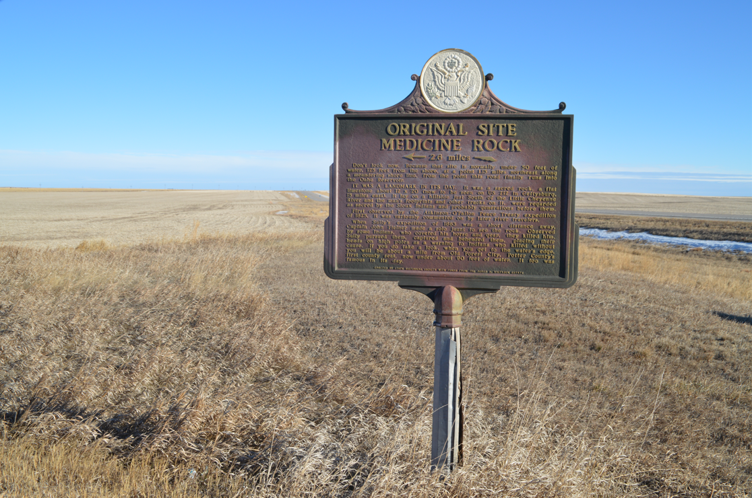

South Dakota Historical Markers

Application and Criteria

Last updated: April 2025

The South Dakota State Historic Preservation Office (SHPO) manages the marker program for the South Dakota State Historical Society. Markers must reflect an accurate and well-rounded historical account of a person(s), place, or event(s). The State Historian may reject an application based on inaccurate, biased, derogatory, or offensive subject material/language.

The South Dakota Department of Transportation (DOT) assists in the installation of markers that are to be placed in the right-of-way of state highways. Installation in other locations is the responsibility of the applicant. The markers come with posts and assembly instructions.

The person or group requesting the marker is responsible for paying for it. The State does not have funding to subsidize marker costs.

How the process works:

1. Applications are submitted to SHPO at the address or email included in the application. Applications should include a proposed text content for the marker.
2. Staff reviews the application and may propose changes/corrections before the marker is approved and the text finalized.
3. If proposed to be located in a state highway right-of-way, staff will assist the applicant in filling out the DOT “Application For Permit to Occupy the Right of Way” form. DOT may suggest an alternative location due to safety/liability issues before approving the permit. Existing pull-off locations for maintenance and accessibility may be preferred.
4. For markers proposed to be located on other properties, the applicant needs to submit a letter of permission from the property owner or public manager of the public land. This should be included with the application. This does not apply if the applicant is the public official(s) or private landowner requesting the marker.
5. After the marker text is approved and placement has been determined, SHPO will forward the final text and details, with your billing address/contact and the delivery address, to Sewah Studios, Inc. (Marietta, Ohio) for manufacturing. The delivery address needs to be “a commercial location with loading access or curb-side service.” See <https://sewahstudios.com/shipping-requirements/> for full requirements. If the marker is being installed in a state right-of-way by DOT, the marker should be shipped to the nearest regional DOT shop for installation.

**Please allow a minimum of three months from the approval of the application to the delivery of the marker. Sewah Studios requires at least nine weeks for manufacturing and shipping times can vary.**

Questions? Email SHPO@state.sd.us or call 605-773-3458 to be directed to the Historic Preservation Specialist for your county.

**Application for the South Dakota Historical Marker Program**

Return completed application to the South Dakota State Historic Preservation Office, 900 Governors Drive, Pierre, SD, 57501 or email to [SHPO@state.sd.us](mailto:SHPO@state.sd.us). Questions? Email [SHPO@state.sd.us](mailto:SHPO@state.sd.us) or call 605-773-3458 to be directed to the Historic Preservation Specialist for your county.

**Applicant Name/Organization:** ____________________________________________________

**Contact Name (if different):** _______________________________________________________

**Contact Phone and/or Email:** _____________________________________________________

**Proposed title for the historical marker:**

**The person(s), place, or event(s) to be commemorated:**

**County the marker is to be placed in:** _____________________________________________

**What is the proposed location of the marker?** Please include digital or hardcopy photographs and/or map of the proposed location.

Examples: 1) Ten miles west of Philip in the right of way of SD HWY 14, 2) Front lawn of Aurora County Courthouse, 3) County Road 56 approximately five miles east of Stickney in a privately owned pasture, 4) In the boulevard of 123 Elm Street in Sioux Falls

**What is the relationship of the proposed location to the person(s), place, or event commemorated by the historical marker?**

Examples: 1) It is the boyhood home of Peter Norbeck, 2) The Sydney to Deadwood Stage crossed at this point, 3) The first motorcycle track in Sturgis was built on this field

**Will the marker be located on a state highway right-of-way?** Yes / No

If No, owner of proposed marker location:______**. Attach letter of permission from property owner.**

**Please answer the following questions.** If typing out on a separate sheet of paper, number your responses to correspond with the items listed below. Please type or print clearly.

1. Describe the person(s), place, or event(s) commemorated by the historical marker.
2. Explain why the person(s), place, or event(s) is significant to South Dakota history.
3. If needed, explain in more detail the relationship between the proposed location and the commemorated person(s), place, or event(s).
4. Do you propose to include an image on the marker? Yes / No  
   If an image is proposed to be included as an etching or a metal photo, include a copy and indicate source of the image. If not in the public domain or produced/owned by the applicant, include a copy of the permission to reproduce the image on the marker. **NOTE: The inclusion of an image can affect the pricing and how many words will fit on the marker.**

**Attach your proposed text.** Use the word limits noted in the pricing list on the next page. The inclusion of an image may limit how many words will fit on a marker. You may include a line at the bottom of the marker to credit the sponsor or funding source for the marker, such as “Erected by the Green Historical Society.”

**Attach a bibliography or list of research sources where you got your information.** Please include photocopies of book and/or article pages with relevant information you used. Insufficient research may result in a marker application being denied.

**Include Billing and Shipping Information if known at this point:**

**Billing Information**

Name: _______________________________

Company/Organization (if applicable):

______________________________________

Phone: _______________________________

Email: ________________________________

Street Address:

_______________________________________

City/State/Zip:

_______________________________________

**Shipping Information**

Name: _______________________________

Company/Organization:

______________________________________

Phone: _______________________________

Email: ________________________________

Street Address:

_______________________________________

City/State/Zip:

_______________________________________

**Select one marker size/type option below.** The estimated word limits are indicated. If continuing text to reverse side (or having different text on reverse), include break point in your proposed text. Using an image on a marker will likely affect the pricing and how many words will fit on the marker.

Marker pricing from Sewah Studios, effective through December 31st, 2025.

30”H x 42”W marker, same text on both sides:

|  |  |
| --- | --- |
| * 5/8” letter size, max 20 lines, ~230 words per side | $3,070.00 |
| * 1” letter size, max 14 lines, ~117 words per side | $2,770.00 |
| * 1 ½” letter size, max 10 lines, ~58 words per side | $2,710.00 |
| * 2” letter size, max 8 lines, ~36 words per side | $2,610.00 |

30”H x 42”W marker, different text on reverse side:

|  |  |
| --- | --- |
| * 5/8” letter size, max 20 lines, ~230 words per side | $3,510.00 |
| * 1” letter size, max 14 lines, ~117 words per side | $3,180.00 |
| * 1 ½” letter size, max 10 lines, ~58 words per side | $3,070.00 |
| * 2” letter size, max 8 lines, ~36 words per side | $3,000.00 |

24”H x 18”W marker, same text on both sides:

|  |  |
| --- | --- |
| * 5/8” letter size, max 15 lines, ~66 words per side | $1,700.00 |
| * 1” letter size, max 11 lines, ~35 words per side | $1,670.00 |

24”H x 18”W marker, different text on reverse side:

|  |  |
| --- | --- |
| * 5/8” letter size, max 15 lines, ~66 words per side | $1,860.00 |
| * 1” letter size, max 11 lines, ~35 words per side | $1,710.00 |

**Also available from Sewah Studios:**To inquire about refurbishment: <https://sewahstudios.com/refurbishment/>   
To order a replacement post: <https://sewahstudios.com/post-order-form/>

|  |  |
| --- | --- |
| Refurbish marker only | $1,200.00 |
| Refurbish marker with cap repair | $1,450.00 |
| Replacement 7 ft. post | $375.00 |
| Replacement 10 ft. post | $475.00 |